Consume Design Document

Main Theme/Idea to explore: Essentially the gathering of power through destroying (or consuming) the weak.

All words in italic won’t exist and are merely descriptors of where they are.

All the screens shown below are our goals for making the game look, WITHOUT assets. Most of the graphics will be replaced with assets in time.

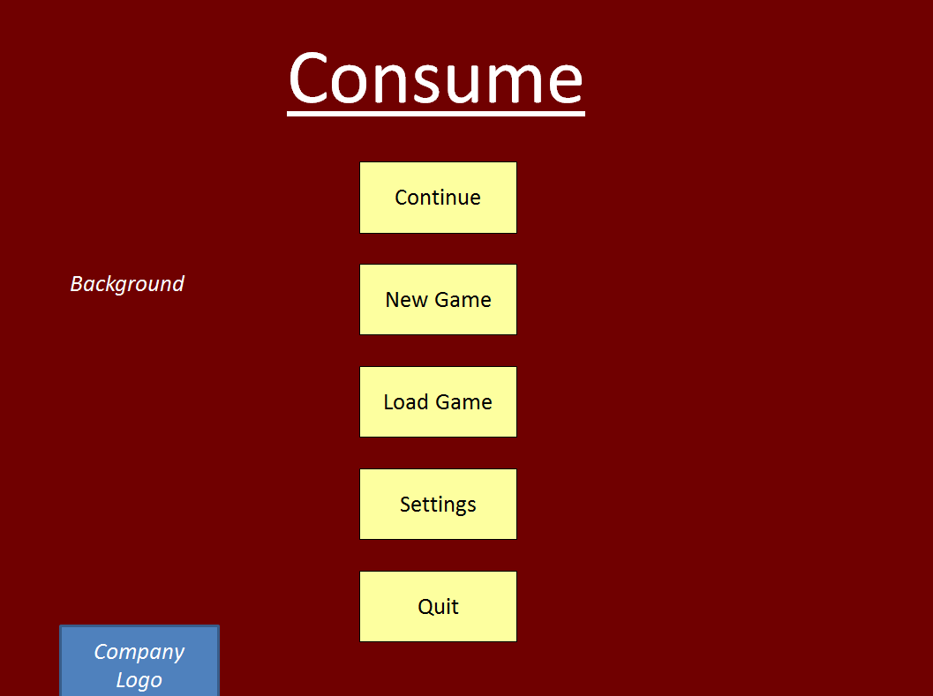

Fig 1: The Main Menu

Main Menu

After a small introduction scene; likely just to tell the player who made it and other contributors the game starts here.

The “Continue” button will load the last save. See “Load Game Menu” and “Save Game Menu” for further details.

The “New Game” button will take the player to the very first level, which will act as a demo.

The “Load Game” button will take the player to the “Load Game Menu”. See that for more details.

The “Settings” button will take the player to the “Settings Menu”. See that for more details.

The “Quit” button will close the game; however the player will still be able to close the game with the window close action i.e. the cross in the corner.

“*Background*” merely describes that the menu will have a simple background, likely a separate asset. The title “Consume” may be part of the asset.

“*Company Logo*” whatever we want to call ourselves and the symbol will go here.

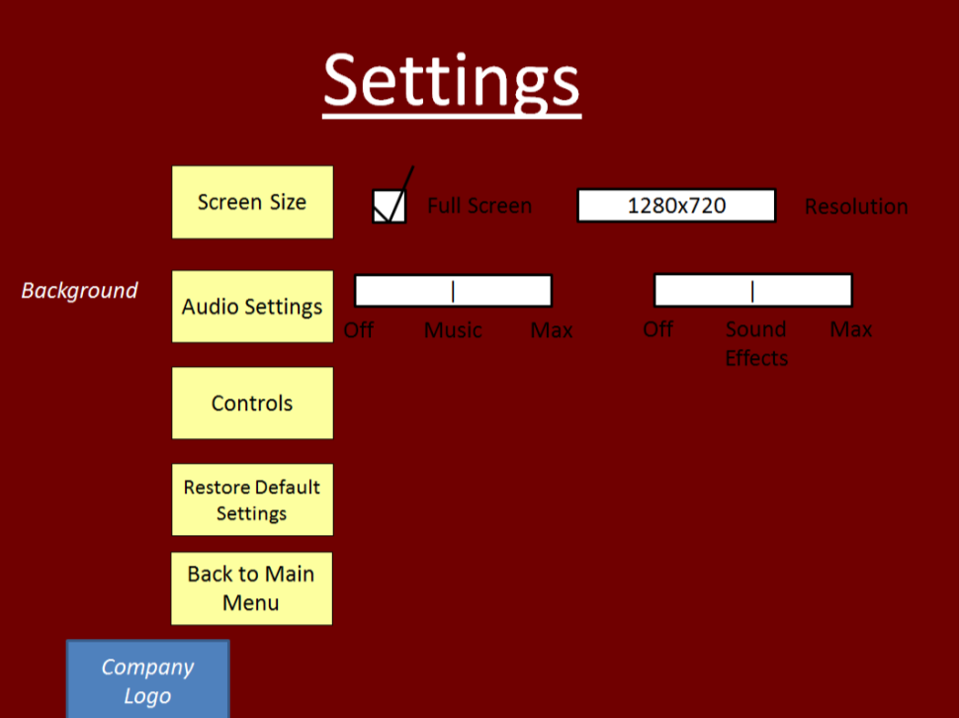

Fig 2. Settings Menu

Settings Menu

“Screen Size” is not a button, all changes to the screen size will be made in the fields to the right. “Full Screen” is a toggle able option which changes the screen from windowed to full screen and vice versa. The “Resolution” will be a dropdown box of options, which are populated by determining the resolution the screen supports (though we may limit the size), which will resize the window, not by scaling but by allowing the player to have more assets on screen e.g. a window with an 800x600 resolution would allow 20 40x40 sprites side by side, but a 1600x1200 resolution would allow 40 of the same sprite.

“Audio Settings” is not a button, all changes to the audio will be made in the fields to the right. “Music” refers to the background music, while “Sound Effects” refer to the small pieces of sound played when particular actions happen e.g. the player being hit. Both music and sound effects should be controllable at any point e.g. Background music will be changed when fighting a boss.

“Controls” is a button and takes the player to the “Controls Menu”.

“Restore Default Settings” will change all the values back to their original values.

“Back to Main Menu” will take the players back to the “Main Menu”. See “Main Menu”.

Finally, all settings are stored as text editable file next to the GUI. This is to allow changes to occur outside the game if needed and to save the settings so the player does not need to keep changing them.

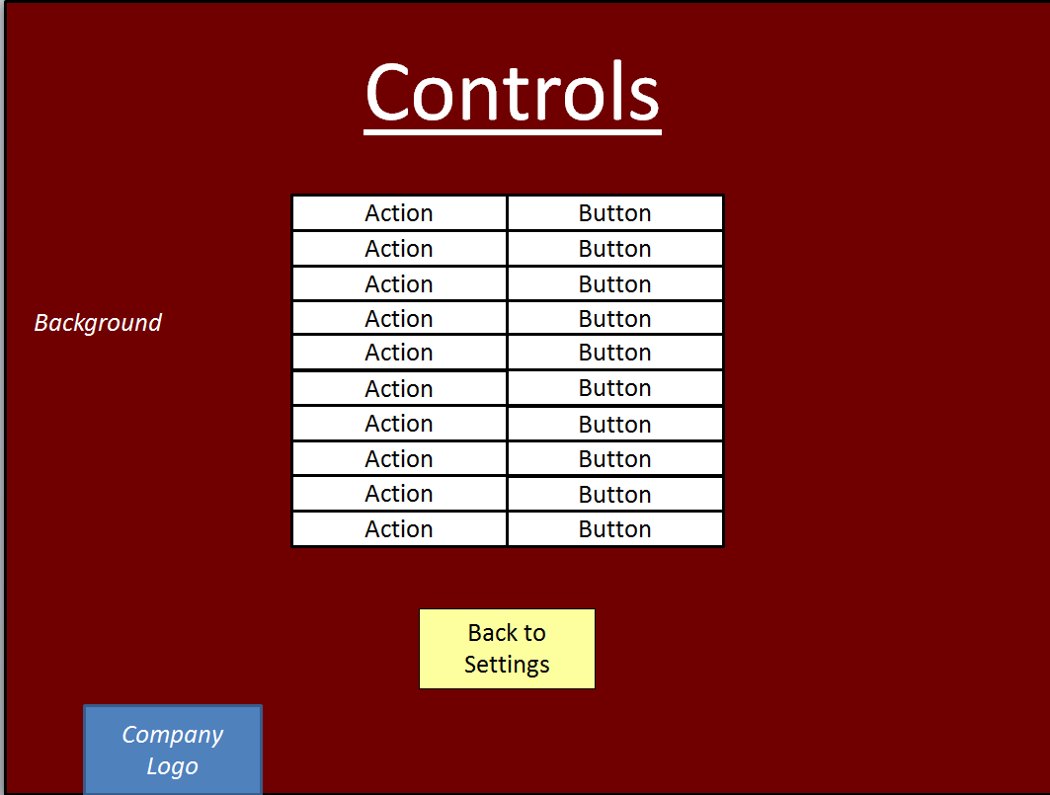

Fig 3. Controls Menu

Controls Menu

All the changes here are stored in the same settings file as the other settings. See “Settings Menu”.

The “Action | Button” table will show all the available actions to a player (and will be scrollable) and allow the player to change them to whatever button they want. If any button is used twice i.e. Action 1 and Action 2 are both activated by the same button. The editor will show the text of those buttons in red, but otherwise will allow it.

The “Back to Settings” button will take the player back to the “Settings Menu”. See “Settings Menu”.

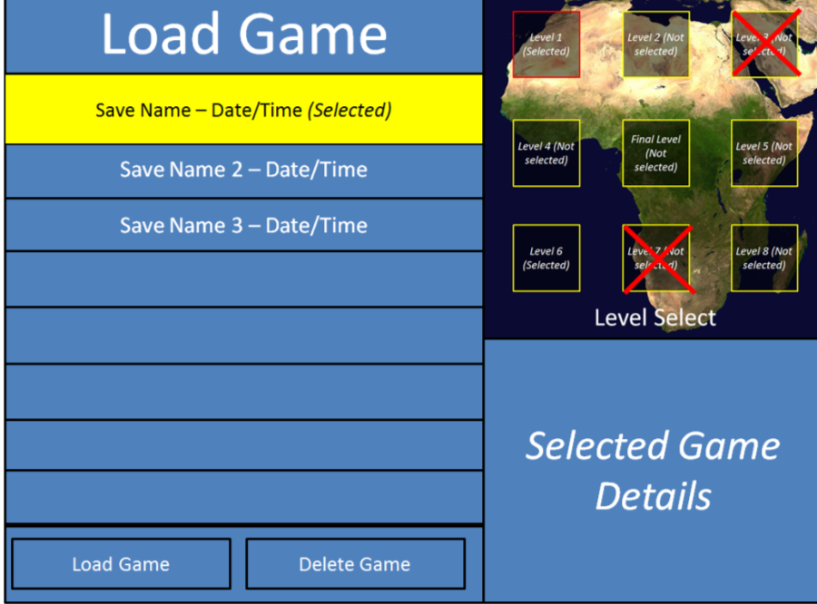

Fig 4. “Load Game Menu”

Load Game Menu

The “Load Game Menu” allows the player to load a previous save. Saves can be automatic and manual. The save remembers which levels the player has completed, which “powers” they have, the save name, and when it was made. Other game details may be added in time.

The menu will show a scrollable list of saves available. There are only 2 autosave slots the eldest of which is overwritten when the game saves automatically. Manual saves will be limited to 21 saves. These saves can be selected and when selected are the target of the “Load Game” and “Delete Game” buttons, and their details are displayed to the left. Levels completed are marked with a red ‘x’ and the “Selected Game Details” will show the rest.

The “Load Game” button will load the selected games data and take the player to the “Level Select Menu”. The “Delete Game” button will delete the selected game, though will ask for confirmation first.

Pressing the “ESC” button or similar will take the player back to the previous menu.

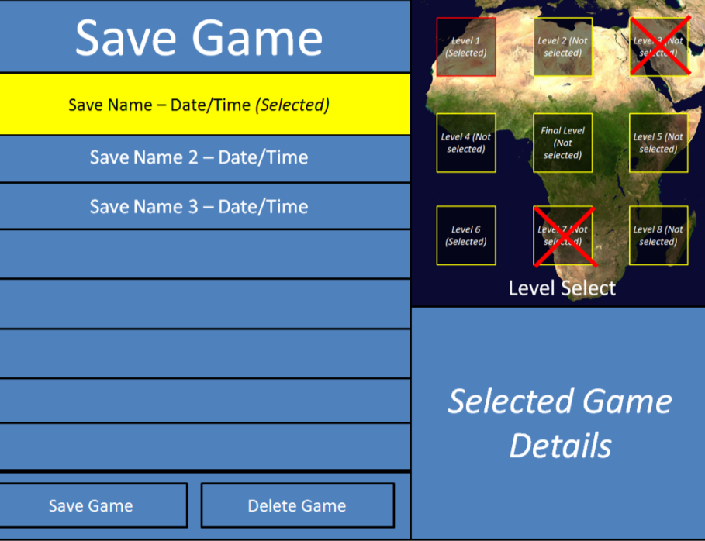

Fig 5. Save Game Menu

Save Game Menu

This menu acts very similarly to the “Load Game Menu”.

Manual saves cannot overwrite auto saves. All other overwrites will require confirmation. The “Save Game” button will store game data about the current game.

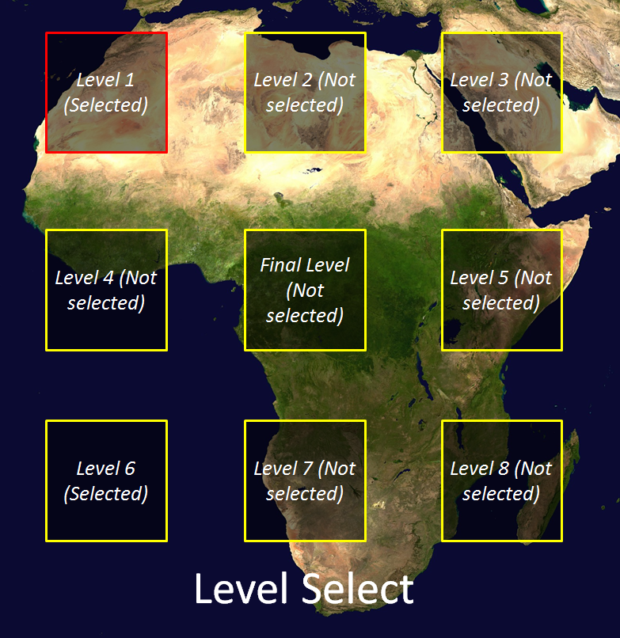

Fig 6. Level Menu

Level Menu

Allows the player to select and start the next level. The selected level is highlighted in red. All levels are available to the player from the start EXCEPT the “*Final Level*” which will be unlocked when the other levels are complete. Until then it is invisible and unselectable.

Pressing the “ESC” button or similar will open the “Pause Menu”. See “Level Menu with Player Menu”.

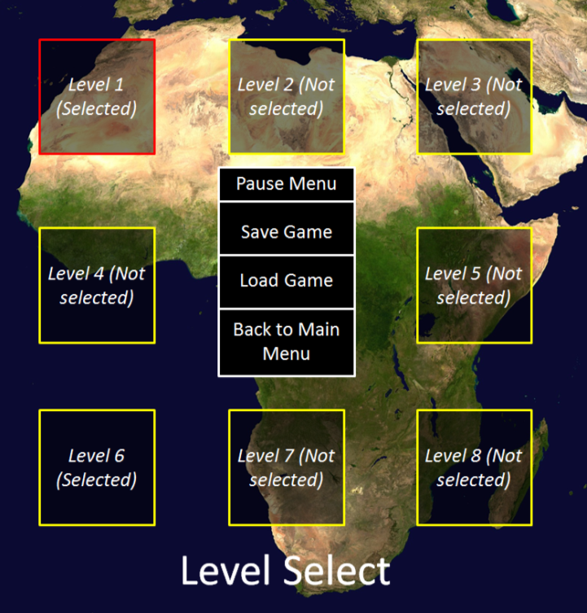

Fig 7. Level Menu with Pause Menu

Level Menu with Player Menu

This another menu on top of the “Level Menu” while open the player cannot access the “Level Menu” controls. See “Level Menu”.

The “Pause Menu” is not a button and will not do anything.

The “Save Game” button will take the player to the “Save Game Menu”. See “Save Game Menu.

The “Load Game” button will take the player to the “Load Game Menu”. See “Load Game Menu.

The “Back to Main Menu” button will take the player to the “Main Menu”. See “Main Menu.

Pressing the “ESC” button or similar will close the “Pause Menu”. See “Level Menu”.

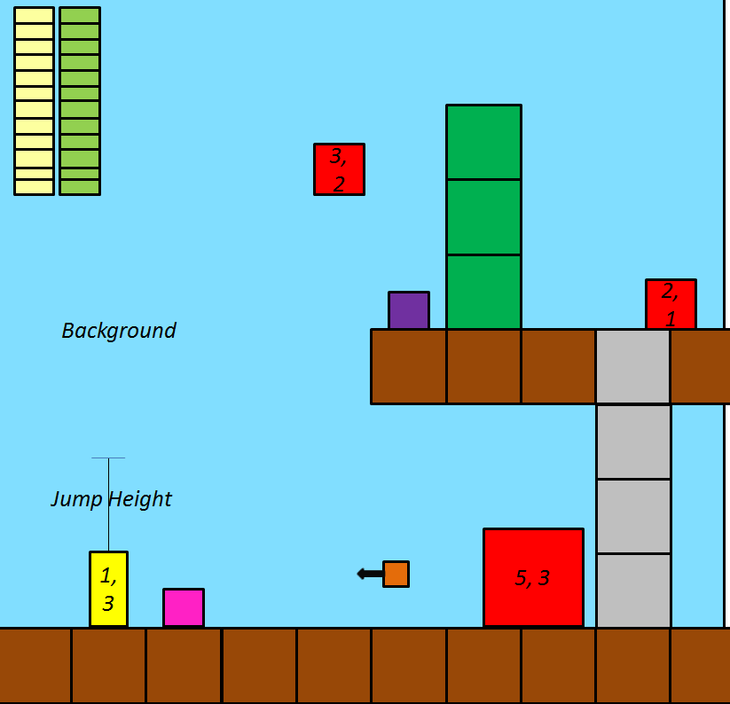

Fig 8. Sample Game Level

Sample Game Level

This shows a sample of a game level and is created for the purpose of describing different aspects of gameplay.

The “Background” is not interact able, though it may move slightly as the player progresses through the level.

The yellow block is the player. The numbers contained within represent the form number (which power is equipped) and the frame number (which frame of the sprite sheet to show) respectively. The “Jump Height” merely denotes the players ability to jump, the height itself will be changed depending on testing.

The red blocks are enemies. The numbers contained within represent the enemy number (which enemy it is) and the frame number (which frame of the sprite sheet to show) respectively. Each enemy type will have a separate sprite sheet and behaviour, while some will utilise similar individual goals e.g. “moveToPlayer”, “shootAtPlayer”, they will all be customisable to allow a variety of enemy behaviours. Touching an enemy hurts the player and MAY hurt the enemy depending on enemy type.

The yellow & green segmented bars represent the player’s “health” and “mana” respectively. Health and mana are regained through “power-ups”, see below, though mana will also have a low regeneration rate. Mana is used to power the player’s abilities. Each ability uses a different amount of mana and some don’t use any. Both health and mana can be increased with “upgrades”, see below.

The pink blocks represent “power-ups”. These are occasionally dropped by enemies and restore health and/or mana in a variety of quantities. They may not be picked up automatically i.e. the player may need to make a special action to pick them up.

The purple blocks represent “upgrades”. These are permanent changes to the player and spawn with the level. When picked up they are no longer spawned in that place. They can be changes to maximum health, maximum mana, movement speed, jump height, and mana regeneration among others.

The orange blocks represent “projectiles”. These act differently based upon their type, but most will damage an enemy in some way and some enemies will be able to use them as well. They will have direction and speed and will automatically be destroyed when leaving the screen.

The brown blocks represent “indestructible blocks”. They can come in a variety of different images, but are both static and indestructible.

The grey blocks represent blocks that can be passed through, though they may react to a player passing through them and may give them temporary special actions to perform e.g. climbing a ladder. They are also static and may not interfere with anything passing through it, unless their behaviour specifically tells them to.

The dark green blocks represent “destructible” blocks, these may be destroyed by a particular attack. Which attack is based upon the block e.g. an ice block will melt when attacked with fire, and will have a suitable animation for its destruction.

Pressing the “ESC” button or similar will open the “Pause Menu”. See “Sample Game Level with Player Menu”.

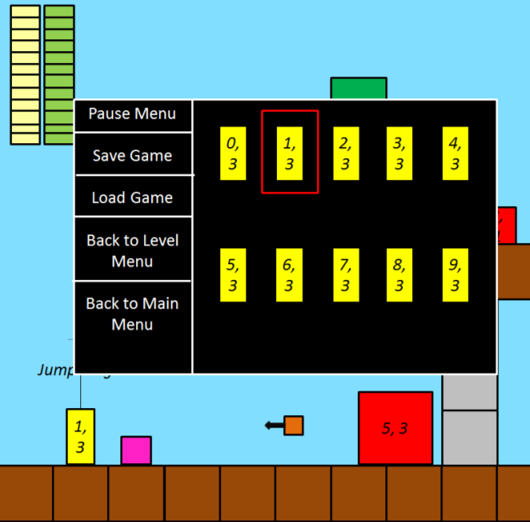

Fig 9. Sample Game Level with Pause Menu

Sample Game Level with Pause Menu

The “Pause Menu” can be accessed using the “ESC” button or similar.

While shown, the game is paused and no actions can be taken in the level by either the player, enemies or computer (e.g. physics).

This pause menu shares functionality with the previous pause menu. See “Level Menu with Pause Menu”.

It has two additional functions though, return to the “Level Menu” and “Choose Power”. The “Choose Power” allows the player to change the power they have equipped. These powers are initially locked and are unlocked over time.

Pressing the “ESC” button or similar will close the “Pause Menu”. See “Sample Game Level”.

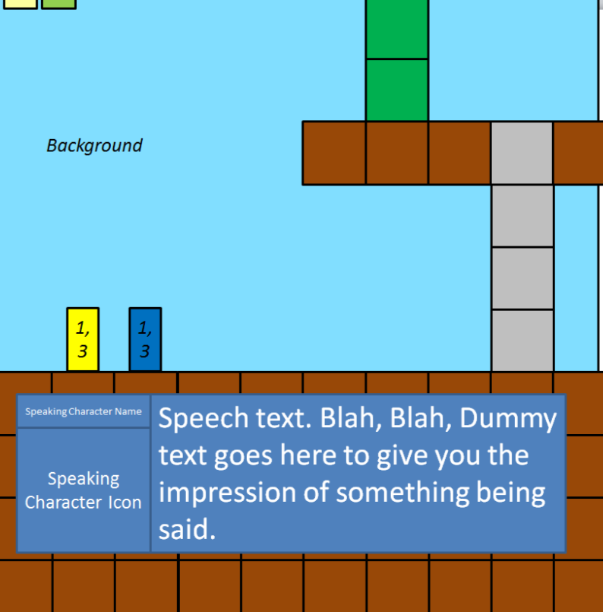

Fig 10. Sample Game Level with Dialogue

Sample Game Level with Dialogue

Some levels may have two or more characters talking. In this case the game is paused similar to when the pause menu is active, and the player may only progress the dialogue.

When in dialogue the camera lowers so that the dialogue box does not obscure the player.

The dialogue box shows the speaking character’s name and character icon. It also shows what they are saying.

When the dialogue ends functionality is returned to normal. See Sample Game Level.

Gameplay

Pixel collision detection

Gravity-

Jumping- Gravity affects vertical speed, horizontal speed can still be affected by controller

“Push” Force- Pushes Object

Climbing- Not affected by gravity while climbing

Game objects have different tags relating to its properties (e.g. affected by gravity, projectile, collisionable)

Different “Layers”- some objects will always be drawn on top of others

Multiple powers- unlocked throughout game, allows the player to use different abilities

Pause menu- allows changing powers and saving

Spawn points- spawn on death

HP- health points

PP- each “power” reduces its own “power points” and requires it to use

Enemy Behaviours- Each enemy will act in a custom way though some will reuse certain sub behaviours (e.g. “catch player”)

Item drops- Objects destroyed by player drops items (each enemy has set of items it can drop randomly)

Asset Handling

Multiple frames of a character for various animations

Loop background music

Sound effects- play on command

Display text on screen- Allow the player to continue to next text box.

Apply colour filters- make screen/assets appear lighter/darker

Misc

Main Menu- with continue (play most recent game), start (start new game), load (load saved game), settings (change aspects about the game such as screen size)

Map Menu- Allows the player to choose the next level

Auto Save feature- game saves are automatic, though can be manually created as well.

Credit Scroll- Play Credits in scrollable fashion

<http://listverse.com/2013/07/18/ten-african-myths-and-legends-2/>

<http://en.wikipedia.org/wiki/Traditional_African_religion>